Project Proposal

Sergio Mateos

Southern New Hampshire University

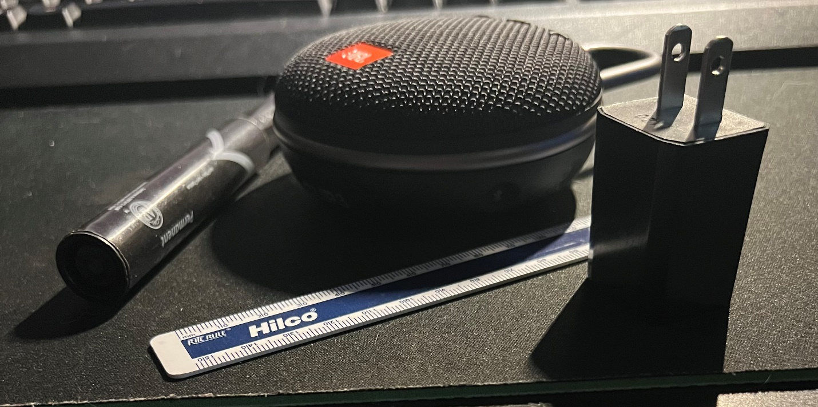Primate Shapes

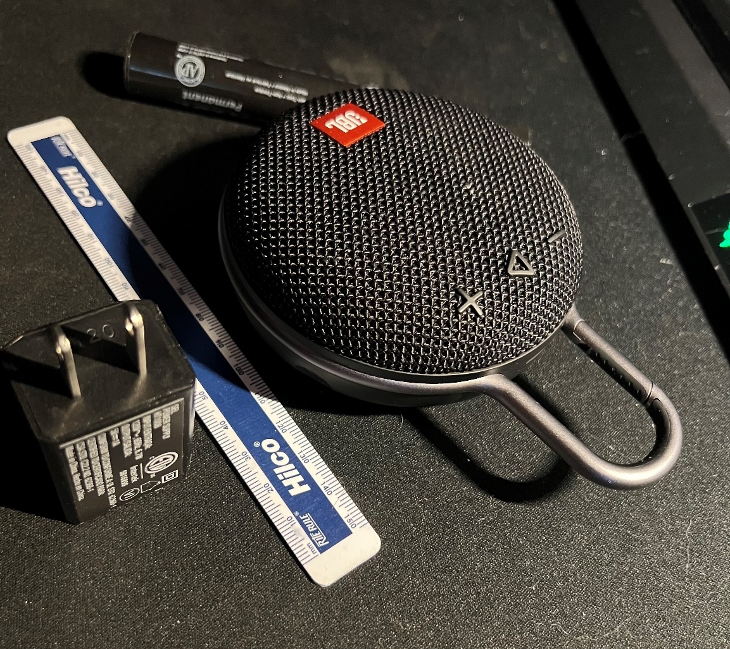

Since the project required four objects in the scene and at least one of the objects need to have two or more primitive shapes, I decide to place these objects in my picture. A marker, speaker, ruler, and wall adapter are in my picture. I would like to choose the wall adapter and the speaker to make them from 2D to 3D. Since my skill in developing shapes are not high enough to pick complicated shapes, I wouldn’t pick difficult shapes, but I think they are challenging for a new developer. For the wall adapter, I will start creating two squares or a rectangle, and at the top of one of the sides large planes that would be connected to the rectangle, and will represent the ports. For the speaker, I will create a torus but with no hole, almost like a sphere but a plane from the bottom and round at the top. The handle of the speaker would be like half of a large torus and the plane square at the top. Also, the desk would be a plane where all the items would be landing.